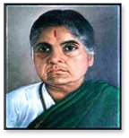

Andhra Mahila Sabha Arts & Science College for Women
Autonomous - NAAC Re-Accredited, OU.Campus, Hyderabad – 500 007

PLACEMENT DRIVE REPORT IN COLLABORATION WITH ANUDEEP FOUNDATION
Date: 1 October 2026
Venue: MV Hall
Time: 10:00 AM to 2:00 PM
Target Group: B.Com (Computers) Final Year Students
Number of Students Participated in Placement Drive: 51
Number of Students Short Listed : 51
1. Introduction
The Placement Cell of AMSASCW, in collaboration with the Anudeep Foundation, organized a campus placement drive for the students of B.Com (Computers) on 1 October 2026 at MV Hall, from 11:00 AM to 2:00 PM. The initiative was aimed at providing students with employment opportunities and facilitating direct interaction with prospective employers.
As part of its continuous efforts to enhance student employability and industry readiness, the Placement Cell, in collaboration with the Anudeep Foundation, conducted a three-month Certificate Programme on Advanced Excel and Power BI for B.Com (Computers) students. A total of 51 students registered for and underwent the training programme. The programme started from 23-07-2026 and concluded on 5-10-2026 ,focused on strengthening students' practical skills in spreadsheet management, data analysis, reporting, visualization, and business intelligence tools, thereby preparing them for industry-oriented career opportunities.
The programme was graced by the presence of Principal, Prof. K. Karuna Devi, who addressed the students and delivered an encouraging speech. She motivated the students to actively participate in the recruitment process, develop their professional skills, and make effective use of the career opportunities provided through the placement drive. Her words of encouragement inspired the students to approach the recruitment process with confidence and a positive attitude.
HR recruiters from various organizations participated in the recruitment process and offered opportunities across areas such as finance, loan processing, relationship management, chat support, and front-office operations.
2. Participating Organizations and Job Opportunities

S. No. | Organization | Position Offered | Salary Offered | Location
1 | Muthoot Finance | Loan Processing Executive | ₹19,000 Per Month | Hyderabad
2 | IDFC Bank | Junior Finance Executive | ₹18,500 per month | Hyderabad
3 | Samarthya Finance | Relationship Executive | ₹15,000 per month | Hyderabad
4 | Writer Business Pvt. Ltd. | Chat Support Executive | ₹18,000 per month | Hyderabad
5 | Groowviatech Solutions Pvt. Ltd. | Front Office Executive | ₹19,500 per month | Hyderabad

3. Recruitment Process
The placement drive provided students with an opportunity to participate in a structured recruitment process conducted by the participating organizations. The process included interaction with company representatives and evaluation of candidates based on their suitability for the respective job roles.
Students were introduced to the participating organizations, job profiles, responsibilities, salary packages, and career opportunities. The interaction enabled students to understand employer expectations and the skills required to succeed in the workplace.
4. Shortlisted Students and Selection Details
The recruitment process resulted in the selection of 51 students for various positions offered by the participating organizations.
S. No. | Organization | Job Role | Salary per Month | Students Selected
1 | Groowviatech Solutions Pvt. Ltd. | Front Office Executive | ₹19,500 | 6
2 | Writer Business Pvt. Ltd. | Chat Support Executive | ₹18,000 | 9
3 | Samarthya Finance | Relationship Executive | ₹15,000 | 12
4 | IDFC Bank | Junior Finance Executive | ₹18,500 | 12
5 | Muthoot Finance | Loan Processing Executive | ₹19,000 | 12
 | Total |  |  | 51

5. Objectives of the Placement Drive
The major objectives of the placement drive were:
- To provide employment opportunities to B.Com (Computers) students.
- To connect students with prospective employers.
- To provide exposure to the corporate recruitment process.
- To familiarize students with career opportunities in finance, banking, customer support, and front-office operations.
- To bridge the gap between academic learning and industry requirements.
- To enhance students' confidence and employability skills.
- To facilitate interaction between students and industry representatives.
6. Outcome of the Drive
The placement drive successfully facilitated employment opportunities for the participating students. The 51 students who participated in the placement drive were selected for various positions across the five participating organizations.
The salary packages offered ranged from ₹15,000 to ₹19,500 per month. The selected students received opportunities in banking and financial services, loan processing, relationship management, chat support, and front-office operations.
The three-month Advanced Excel and Power BI Certificate Programme, which was undertaken by 51 registered students, provided them with additional practical and industry-oriented skills in data handling, analysis, reporting, and business applications.
7. Conclusion
The placement drive organized by the Placement Cell of AMSASCW in collaboration with the Anudeep Foundation was a significant initiative towards enhancing the employability and career prospects of B.Com (Computers) students.
The combination of skill-based training through the three-month Advanced Excel and Power BI Certificate Programme and direct interaction with employers through the placement drive provided students with valuable preparation and exposure to the professional environment.
The Placement Cell expresses its sincere gratitude to Principal Prof. K. Karuna Devi for her motivating address and valuable guidance, and to the Anudeep Foundation and participating organizations for their support and cooperation in making the initiative successful.
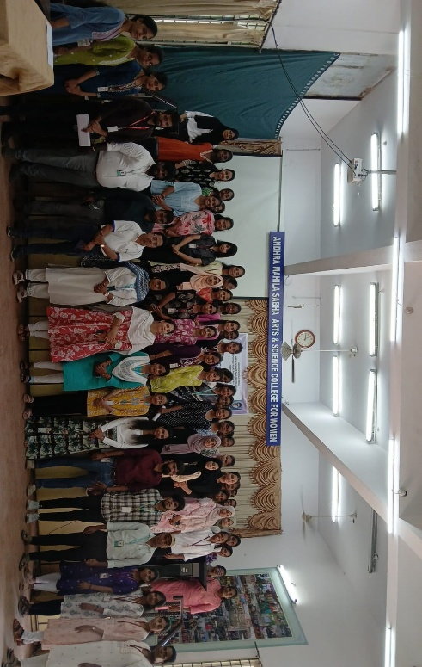
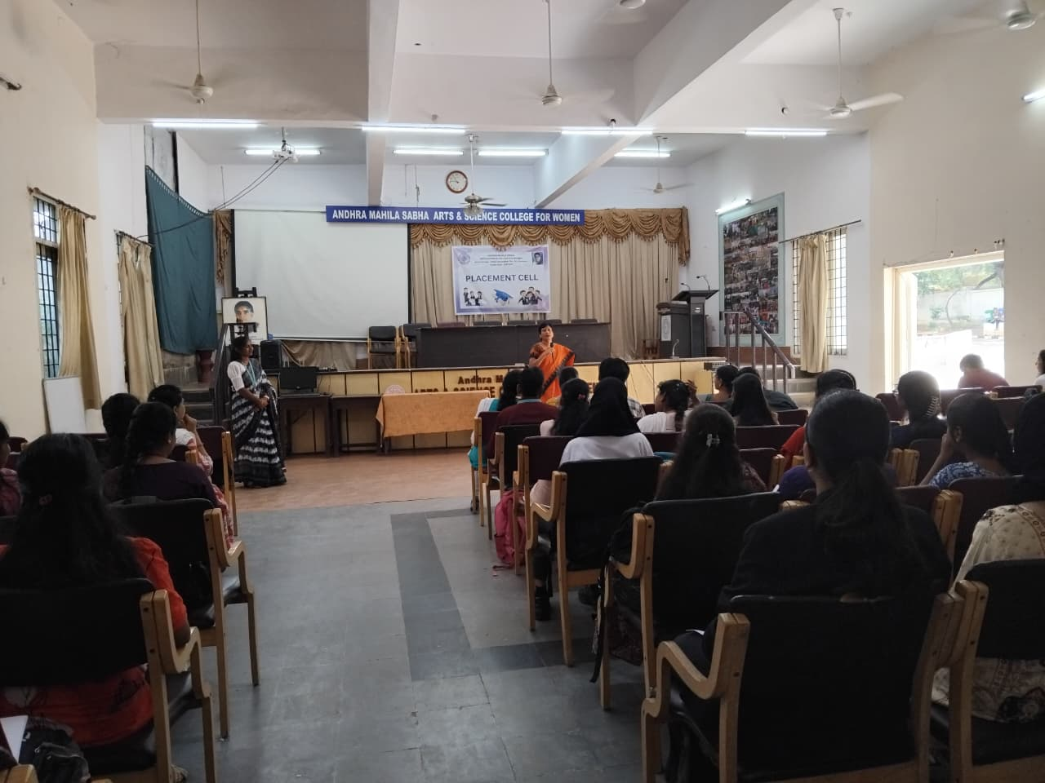
The successful selection of 51 students demonstrates the institution's continued commitment
to strengthening students' employability, industry readiness, and career development.
