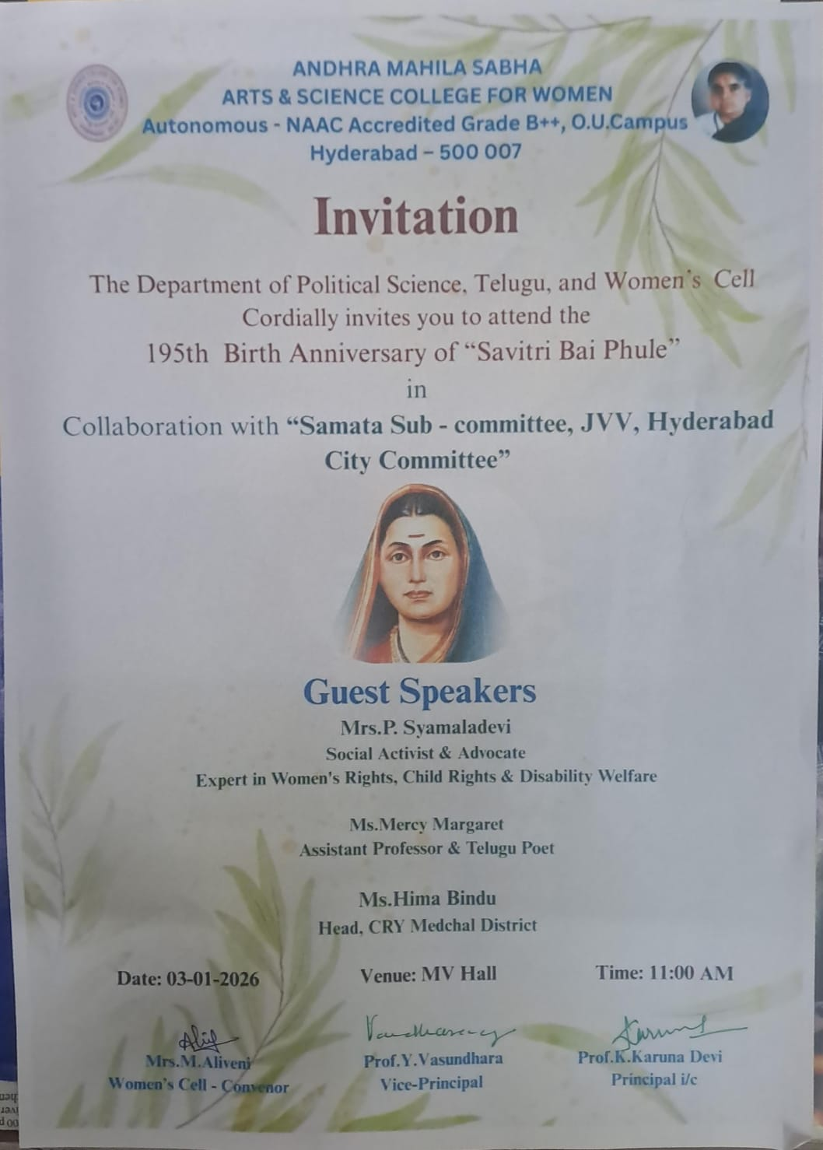

REPORT ON THE 195th BIRTH ANNIVERSARY OF SAVITRIBAI PHULE

The Department of Political Science, Telugu and the Women’s Cell of Andhra Mahila Sabha, Arts & Science College for Women, in collaboration with the Samata Subcommittee, JVV, Hyderabad, organized the 195th Birth Anniversary celebrations of Savitribai Phule on 3 January 2026.150 students participated in the programme.
Ms. Shruti, BBA II Year student, warmly welcomed the dignitaries, faculty members, and students. In her welcome address, she recalled the invaluable contributions of Savitribai Phule (3 January 1831 – 10 March 1897) as India’s first woman teacher and a pioneering social reformer. She then invited Prof. K. Karuna Devi, Principal i/c, Prof. Y.Vasundhara,Vice Principal,The Chief Guest, Smt. P. Shyamaladevi,Social Activist and Advocate, Smt. Hima Bindu, Head, CRY Medchal District, Smt. Mercy Margaret, Assistant Professor and renowned Telugu poet and Dr. A. Pramila, IQAC Coordinatorto the dais. After the prayer, the dignitaries lit the ceremonial lamp, symbolizing the awakening of knowledge.
Prof. K. Karuna Devi, Principal i/c, addressed the gathering and emphasized that true societal progress is possible only through women’s education. She stated that the path shown by Savitribai Phule remains relevant even today and that women's education leads to the development of the family, society, and nation.Dr. P. Rajani, Former Secretary, AMSASCW, spoke about the current status of women's movements and the inspirational legacy of Savitribai Phule.Prof. Y.Vasundhara, Vice Principal, recalled the hardships faced by Savitribai Phule in promoting women’s education and urged the present generation to carry forward her ideals.
Dr. A. Pramila, IQAC Coordinator, highlighted how Savitribai Phule’s life continues to inspire today’s youth in the pursuit of education and social equality.

Students’ Presentations
Students delivered diverse and meaningful presentations on the life and work of Savitribai Phule:
- Sai Renuka, B.Com(CA) II Year spoke on Savitribai Phule’s struggles, her dedication to education, and the support of Jyotirao Phule in her journey.
- Manjushree, B.A (EPP) II Year recited a poem.
- Ayesha, BBA I Year delivered a speech on Savitribai Phule’s personality and life.
- Vasantha, Pallavi, Indu, Teja, Shravani, Anusha, Praneetha, and Vichitnalalasa, B.A (EPP) III Year presented a skit depicting key events from her life.
- Sumalatha, B.Com( C.A) IInd Year sang a meaningful song inspired by Savitribai Phule’s contributions.
- Sharanya , PG Student, O.U read a poem on Savitribai Phule.
- Gayatri,JVV delivered a speech and motivated the students with Savitribai Phule’s sacrifices for women education.
Through these presentations, students highlighted issues related to women’s rights, education, and social equality, echoing Savitribai Phule’s ideals.

Chief Guests’ Addresses
The Chief Guest, Smt. P. Shyamaladevi, Social Activist and Advocate, spoke about:
- Challenges faced by Savitribai Phule as a learner and teacher
- Schools established by Savitribai Phule and Jyothi Rao Phule
- The role of men in women’s development
- The importance of education
- Savitribai Phule’s Service during the plague epidemic
She created awareness on women’s rights and development, noting that Savitribai Phule’s idea’s continue to serve as a foundation for social transformation.
Smt. Hima Bindu, Head, CRY Medchal District, elaborated on Savitribai Phul’s great contribution to women Education and Children's rights.She has been actively serving in slum communities and advocating for the protection of children’s rights.She stressed the need to strengthen government education systems and called upon society to assume responsibility for child protection and safeguarding children's rights.
Smt. Mercy Margaret, Assistant Professor and renowned Telugu poet, spoke on the importance of education and its transformative role in personality development.
Ms. Indu, B.A (EPP) III Year student, proposed the vote of thanks, expressing gratitude to the dignitaries, faculty, organizers, and students. The programme concluded with the National Anthem, leaving a powerful message on women's education and social equality, effectively conveying Savitribai Phule’s ideals to the present generation.

Dr. Y.Vasundhara
Head, Dept.of Political Science

