A REPORT ON INTERNATIONAL HUMAN RIGHTS DAY CONFERENCE
The Department of Political Science, in collaboration with Dalit Sthree Sakthi, organized a conference on International Human Rights Day at 11:00 a.m. on 09-12-2025 in the Seminar Hall, Library. 70 students participated in the programme.
The programme began with a warm welcome by Falak Khan, B.A (EPP), III Year. She invited the dignitaries Smt. Jhansi Geddam, Advocate and National Convener, Dalit Sthree Sakthi, Prof. E. Sudha Rani, Director, G. Ram Reddy Centre for Research & Development, DBRAOU,Dr.Sudarshan, Director, PACPET, Osmania University, Hyderabad,Prof. K. Karuna Devi, Principal I/c,Prof. Y. Vasundhara, Vice-Principal; Dr. A. Pramila, IQAC Coordinator and Ms. G. Hima Bindu, Assistant Professor of Economics. Around 150 students attended the programme.
Smt. Jhansi Geddam highlighted the importance of the day and spoke about the 16 Days of Activism initiated by the United Nations to eradicate violence against women. She also explained the work of Dalit Sthree Sakthi, an organisation dedicated to empowering Dalit and tribal women and addressing violence against them.
This was followed by a session by Prof. E. Sudha Rani, Director, G. Ram Reddy Centre for Research and Development, DBRAOU. She spoke about the UN Campaign on the Violation of Rights, the importance of Women Empowerment, and the Domestic Violence Act. She cited reports from the National Crime Records Bureau (NCRB) and the United Nations, stating that 30% of women have experienced sexual violence, and one in three women faces some form of violence.
She also discussed digital violence, explaining how personal information shared on social media platforms can be misused. She elaborated on various forms of digital violence such asemail threats, misuse of artificial intelligence, and other cybercrimes, creating awareness among the students.
Next, Prof. Y. Vasundhara, Vice-Principal, delivered a message on Fundamental Rights, Women’s Rights, and Human Rights. She advised the women students on ways to protect themselves from potential threats and emphasized the need to remain cautious while sharing personal information on digital platforms. She encouraged the students to safeguard their bodies and lives from harmful individuals and to empower themselves with awareness and confidence.
Another speaker, Dr. Sudharshan Balaboina, Assistant Professor and Director, PACPET, Osmania University, Hyderabad, spoke about the role of digital media platforms, socio-economic and political aspects of online interactions, and different forms of violence. He also discussed cyber feminism and emphasized the significant contributions of Dr. B. R. Ambedkar, who identified and encouraged the talents of women and fought for gender equality. He explained various types of violence, including physical violence, violence among family members, peers, and psychological abuse, stressing that violence is not limited to physical harm but also includes mental torture, verbal abuse, and inappropriate touch.
The session became interactive as students raised several thoughtful questions.
The programme concluded with a vote of thanks delivered by Akhila, B.A III Year.

Prof. Y. Vasundhara
Head, Department of Political Science

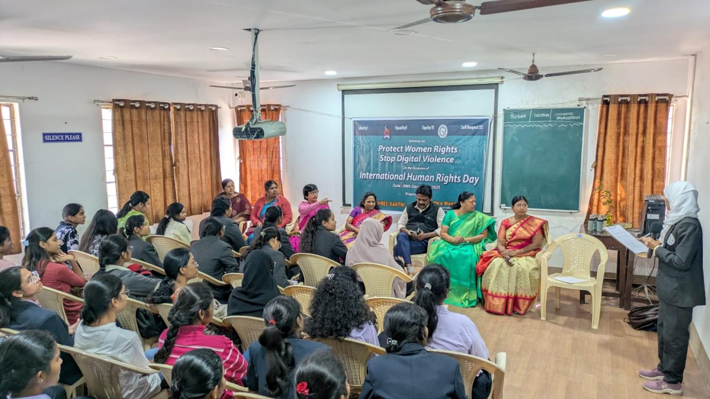
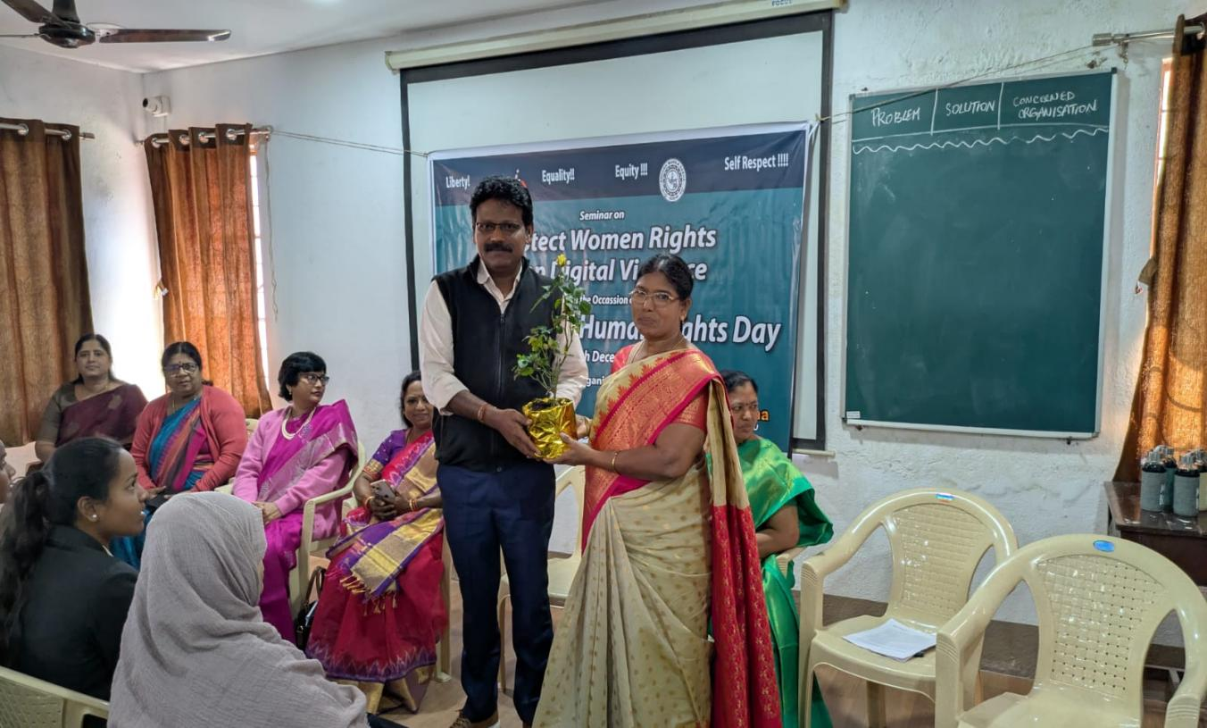

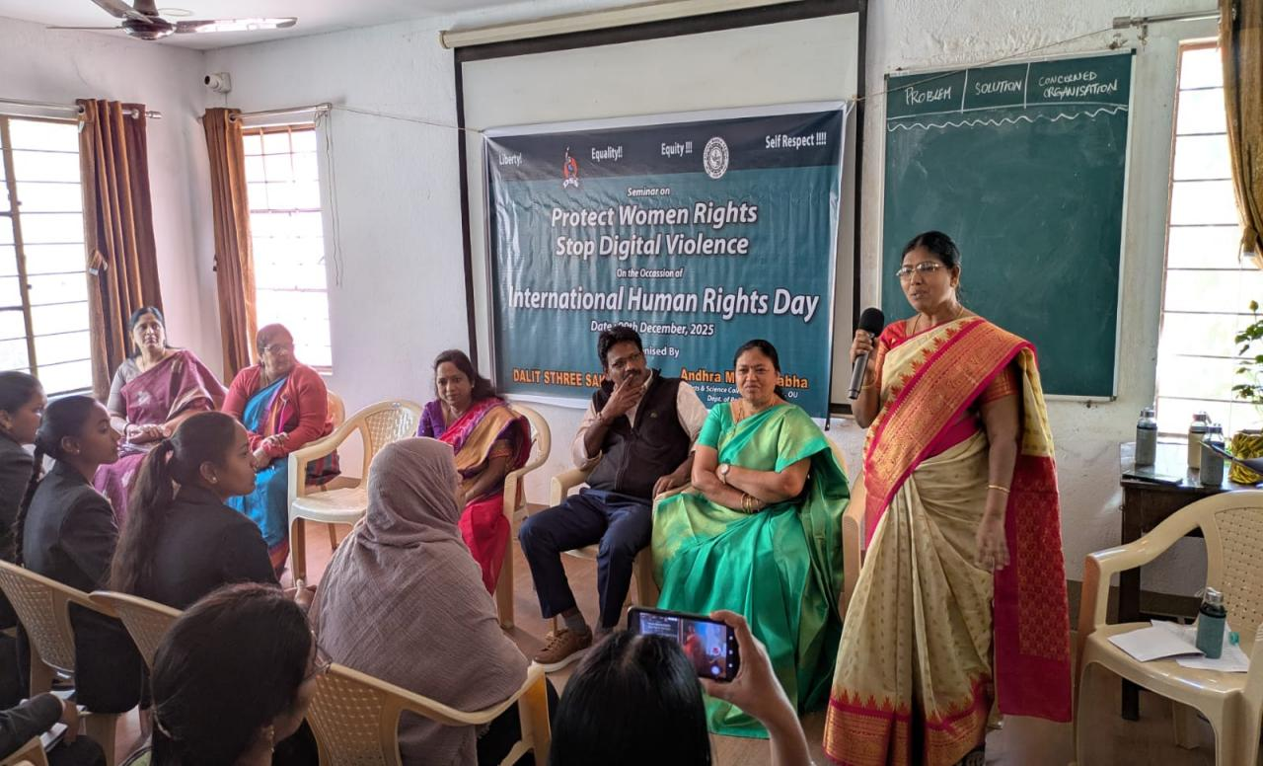
Message by Prof.Y.Vasundhara, Vice- Principal
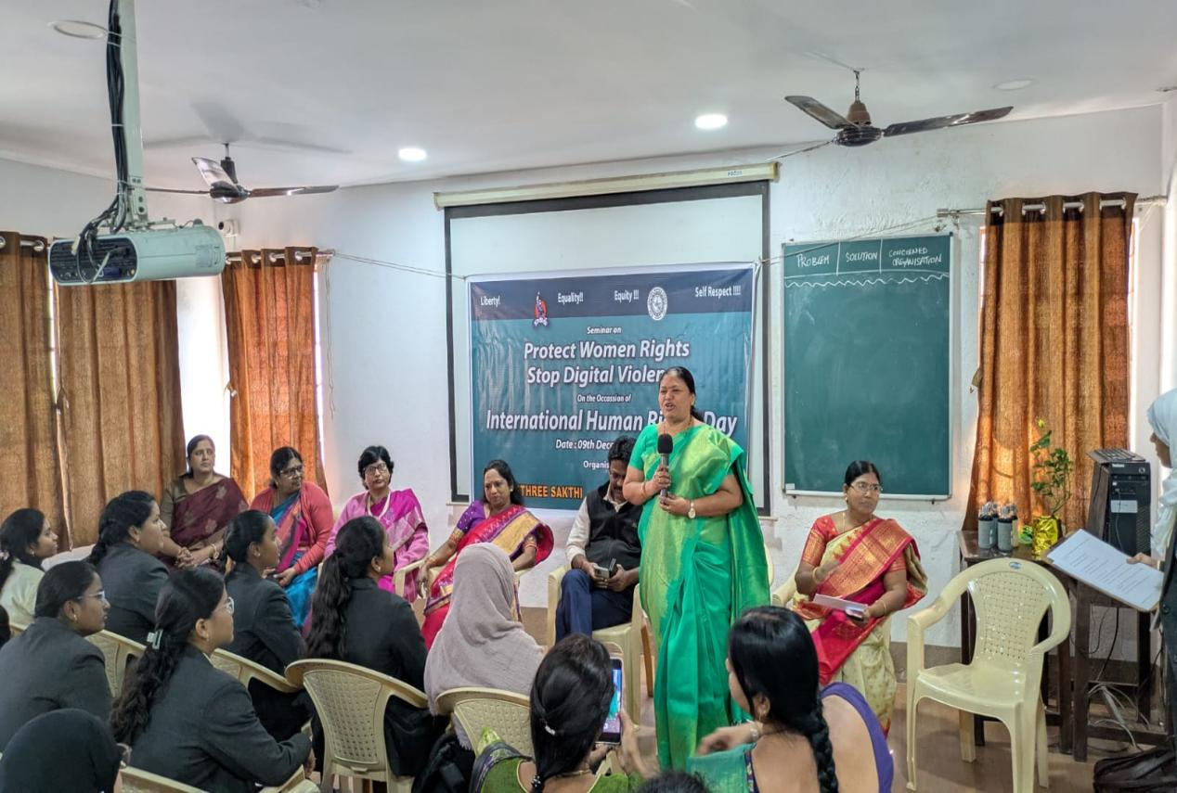
Lecture by Mrs. Jhansi, Gaddam, Advocate and National Convenor, Dalit Sthree Sakthi

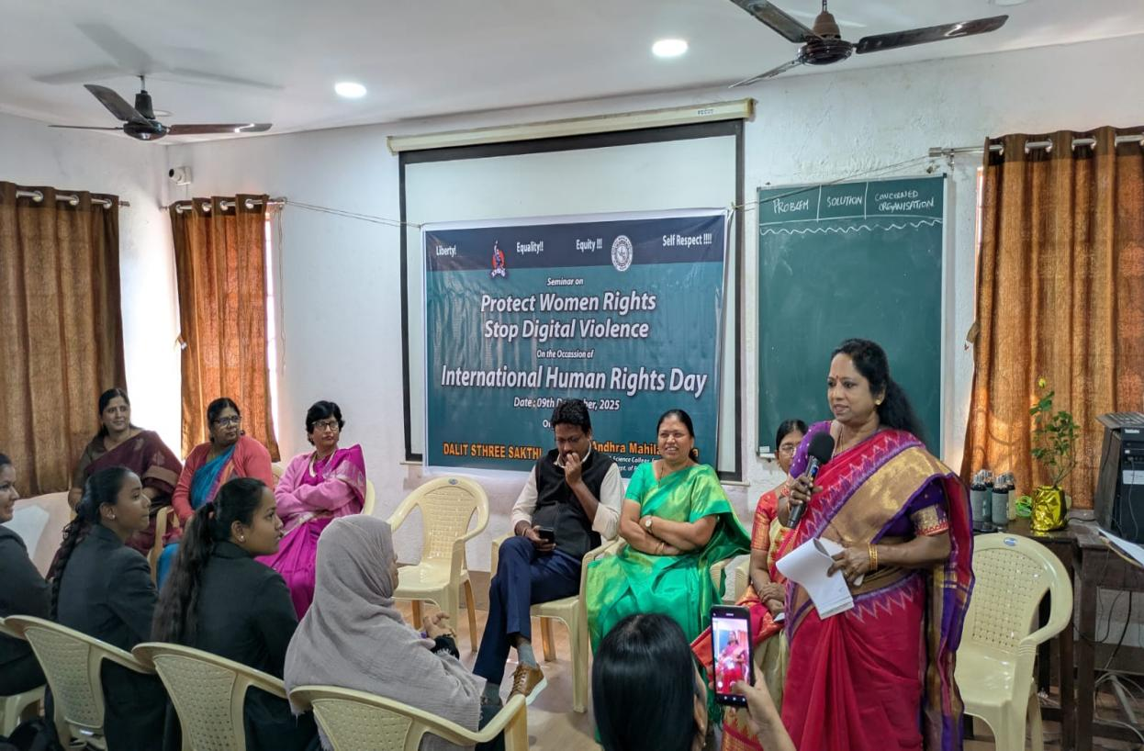
Lecture by Prof. E. Sudha Rani, Director, G. Ram Reddy Centre for Research & DevelopmentDBRAOU
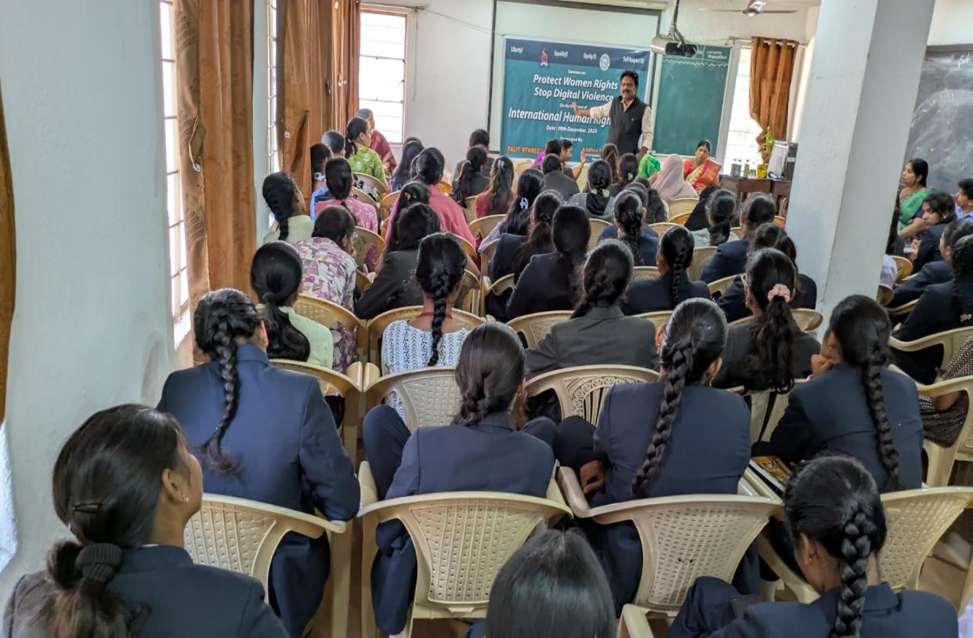
Lecture by Dr.Sudarshan, Director, PACPET, Osmania University, Hyderabad

