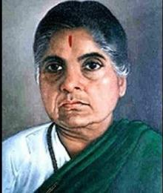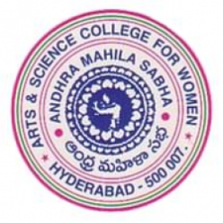
Andhra Mahila Sabha
Arts & Science College For Women
Autonomous-NAAC Accredited Grade B⁺⁺
O.U Campus,Hyderabad-500 007

Annual Day Report
Andhra Mahila Sabha Arts & Science College for Women, Autonomous, O.U. Campus, Hyderabad, witnessed a vibrant and memorable celebration of its Annual Day on 17th March 2026, marking not just an event, but a heartfelt journey of achievements, talents, and togetherness.
In the days leading up to the grand celebration, the campus was filled with excitement and creativity as a series of competitions were conducted from 11th to 13th March 2026 for both Teaching, Non-Teaching Staff, and Students.
These events provided a wonderful platform for participants to express their talents beyond academics. Competitions such as Singing, Dancing, Cooking, Mehendi, Vegetable Carving, Flower Arrangement, and Rangoli transformed the college into a hub of creativity and enthusiasm.

The active participation of staff and students reflected the vibrant culture of the institution. The events not only encouraged creativity but also strengthened bonding, teamwork, and a sense of belonging among all members of the college.
The much-awaited Annual Day began at 10:55 AM with a dignified Guard of Honour presented by the Scouts & Guides students, symbolizing discipline, respect, and unity.
The programme formally commenced with a warm welcome to the dignitaries by students C.P. Ankitha and K. Sai Varsha, creating a gracious and inviting atmosphere.
The Secretary & Correspondent, Sri Ch. V. Sai Prasad, delivered an inspiring welcome address, emphasizing the institution’s mission of empowering young women through quality education and values.

The Principal, Prof. K. Karuna Devi, presented the Annual Report, highlighting the institution’s remarkable achievements in academics, co-curricular activities, and student success. Her address reflected the college’s continuous progress and unwavering commitment to excellence.
A proud moment for the institution was the release of the College Magazine, showcasing the creativity, innovation, and intellectual contributions of students and faculty.

The event was graced by distinguished dignitaries whose presence added great value and inspiration:
- Smt. Usha Kanda, President, DDMS (AMS), motivated students with her powerful message on discipline, leadership, and self-confidence.
- Mr. Narasimha Manchukonda, Director, Manchukonda, encouraged students to prepare for future challenges with determination and clarity.
- The Chief Guest, Mrs. K. Damayanthi, IAS (Retd.), delivered a deeply inspiring speech, urging students to dream big, uphold integrity, and contribute meaningfully to society.

The programme reached an emotional high with the felicitation of best workers and honoured guests, recognizing dedication, commitment, and service to the institution.
The Prize Distribution Ceremony was a moment of pride and joy, as students were honoured for their excellence in:
- Academics
- Cultural Activities
- Sports
Each award symbolized hard work, perseverance, and the spirit of achievement, making it a truly memorable experience for the recipients and audience alike.
The formal programme concluded with a heartfelt Vote of Thanks by Vice Principal, Prof. Y. Vasundhara, expressing gratitude to all dignitaries, organizers, and participants.
The celebrations continued with colourful cultural performances, where students showcased their extraordinary talent through music, dance, and creative expressions. The stage came alive with energy, leaving the audience mesmerized and filled with joy.

The Annual Day celebrations were not just a display of achievements, but a beautiful reflection of the college’s spirit of unity, creativity, and excellence. From enthusiastic participation in competitions to the grand celebration of success, the event stood as a testament to the institution’s commitment to holistic development.
It was truly a day filled with emotion, pride, inspiration, and unforgettable memories, reminding everyone that success is a journey best celebrated together.

