Andhra Mahila Sabha Arts and Science College for Women (Autonomous - NAAC Reaccredited),
O.U. Campus Road, Hyderabad - 500007

Report on “Anemia Awareness & Screening Program” Organized by: Department of Zoology on 30th August 2025 Time: 10:00 AM

The program was attended by Prof. K. Karuna Devi, Principal In-charge of the Institution, Prof. A. Pramila, IQAC Coordinator and Head I/c Department of zoology, Faculty of zoology G.Ruchita and Nanda Kulkarni, Students from all the streams.

Objective of the Program:
The primary objective of the program was to raise awareness about anemia, its causes, symptoms, and preventive measures. Additionally, a hemoglobin screening test was conducted to identify individuals at risk of anemia and promote early diagnosis and treatment. The initiative aimed at empowering students and staff with knowledge to manage and prevent anemia, which can have significant impacts on health, especially among young women.
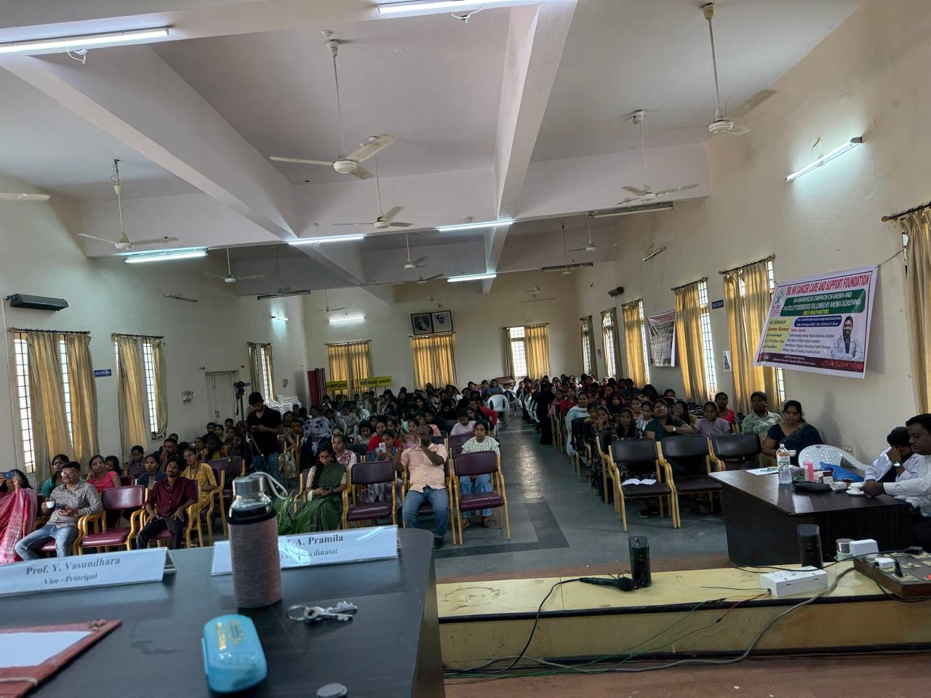

Principal's Address:
The event commenced with an inspiring welcome address by Prof. K. Karuna Devi, Principal In-charge of the institution. Prof. Karuna Devi set the tone of the event by emphasizing the critical role that hemoglobin plays in maintaining overall health. She underscored the importance of healthy blood levels for proper physiological functions, particularly among young women, who are more susceptible to anemia due to factors such as menstruation and inadequate nutrition.
Prof. Karuna Devi highlighted the rising prevalence of anemia among adolescents and young adults, attributing it to poor diet, lack of awareness, and failure to seek timely medical help. She encouraged everyone to prioritize their health by undergoing regular health check-ups, adopting a balanced diet, and staying vigilant about their health status. Her speech also stressed the need for preventive measures such as increased intake of iron-rich foods and iron supplementation when necessary.
Prof. Karuna Devi's address set a positive tone for the rest of the event, emphasizing that early screening and educational outreach are essential steps toward better health outcomes for the community.

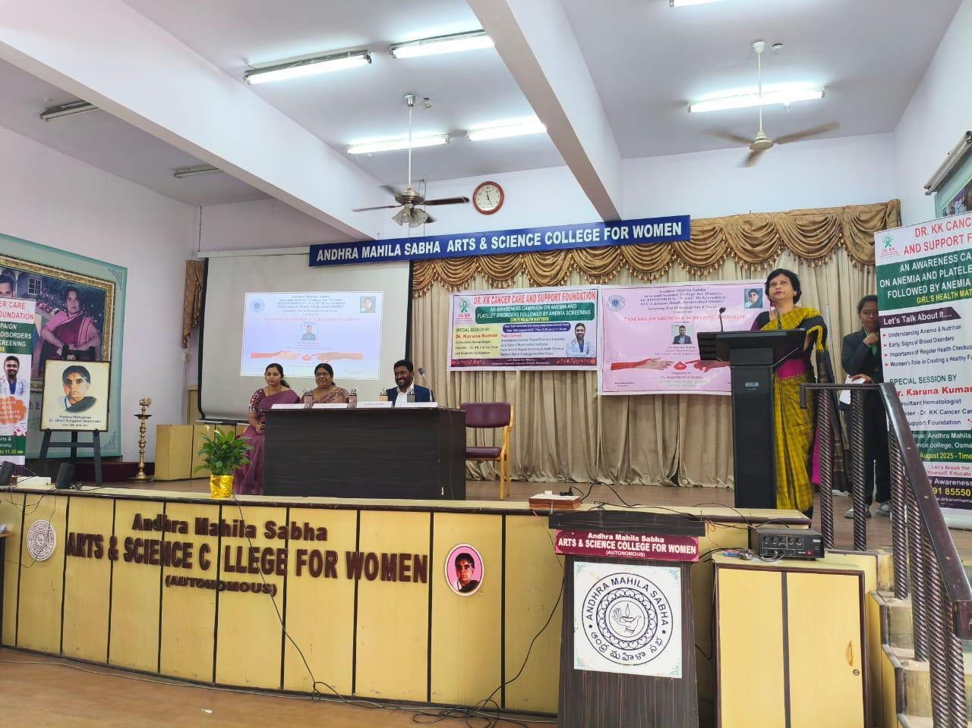

Guest Speaker's Lecture:
The highlight of the program was the informative lecture delivered by Dr. Karuna Kumar, an expert hematologistassociated with the KK Cancer Care & Support Foundation. Dr. Kumar brought valuable insights to the event by focusing on the prevalence of anemia, especially among women, and the impact it can have on overall health and productivity.
Dr. Kumar explained the different types of anemia, including iron-deficiency anemia, vitamin B12 deficiency, and folate-deficiency anemia. He elaborated on the common symptoms of anemia such as fatigue, weakness, paleness, and shortness of breath, which often go unnoticed, leading to delayed diagnosis and treatment. Dr. Kumar also emphasized the importance of proper nutrition in preventing anemia.
Key points from Dr. Kumar's lecture included:
- The need for iron-rich foods like leafy greens, legumes, red meat, and fortified cereals.
- The importance of vitamin B12 and folate for the production of healthy red blood cells.
- The diagnostic methods for identifying anemia, including blood tests like the complete blood count (CBC) and hemoglobin concentration test.
- The available treatments for anemia, such as iron supplements, vitamin injections, and lifestyle modifications.Balanced diet plays a crucial role in preventing and managing anemia. To boost iron levels in the blood, it is recommended to include iron-rich foods such as leafy green vegetables along with dry fruits like anjeer (figs). Anjeer is a good source of iron and, when consumed with leafy greens such as spinach or fenugreek, it helps improve hemoglobin levels more effectively. This combination not only enhances iron intake but also supports better absorption, thereby helping the body recover from iron deficiency anemia.
Dr.karuna Kumar also discussed the importance of early intervention and regular health check-ups to prevent the complications associated with untreated anemia, such as impaired immune function, increased fatigue, and reduced cognitive performance. His session proved to be an eye-opener for many attendees who were previously unaware of the various factors contributing to anemia and its treatment options.
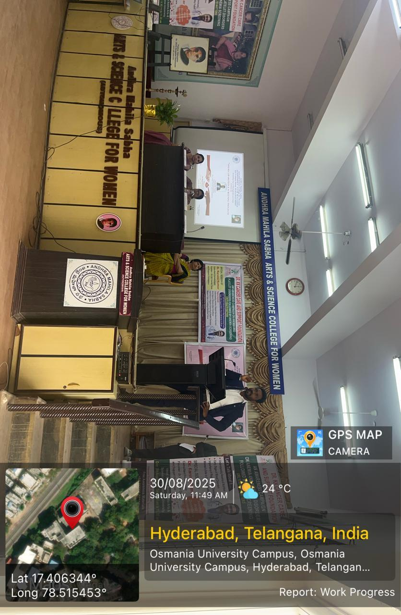

Faculty Interaction:
An insightful interaction took place between Prof. A. Pramila, IQAC Coordinator and Head I/cDepartment of zoology , and Dr. Karuna Kumar during the session. Prof. Pramila raised important academic and practical queries related to anemia awareness among college students and effective dietary interventions. Dr. Karuna Kumar appreciated the relevance of her questions and provided detailed responses regarding nutritional approaches and the importance of integrating health education into academic settings. This exchange added significant value to the session and encouraged students to approach anemia from both scientific and real-life perspectives.
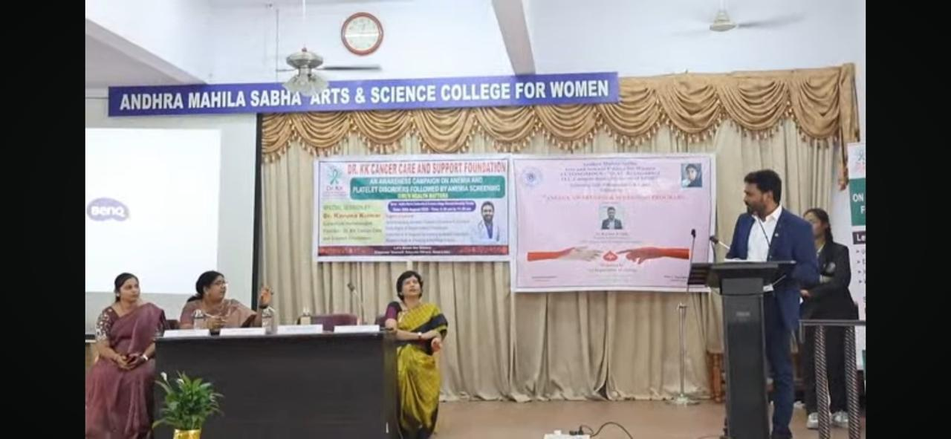

Program Highlights:
The program consisted of several key activities designed to engage participants and provide them with actionable health information:
- Hemoglobin Screening:
One of the central features of the program was the on-the-spot hemoglobin screening conducted to 100 students, faculty and staff members. The screening allowed participants to assess their hemoglobin levels, helping identify those who might be at risk for anemia. The screening also provided immediate feedback, enabling participants to take appropriate measures, including seeking medical advice and adjusting their diet if necessary.

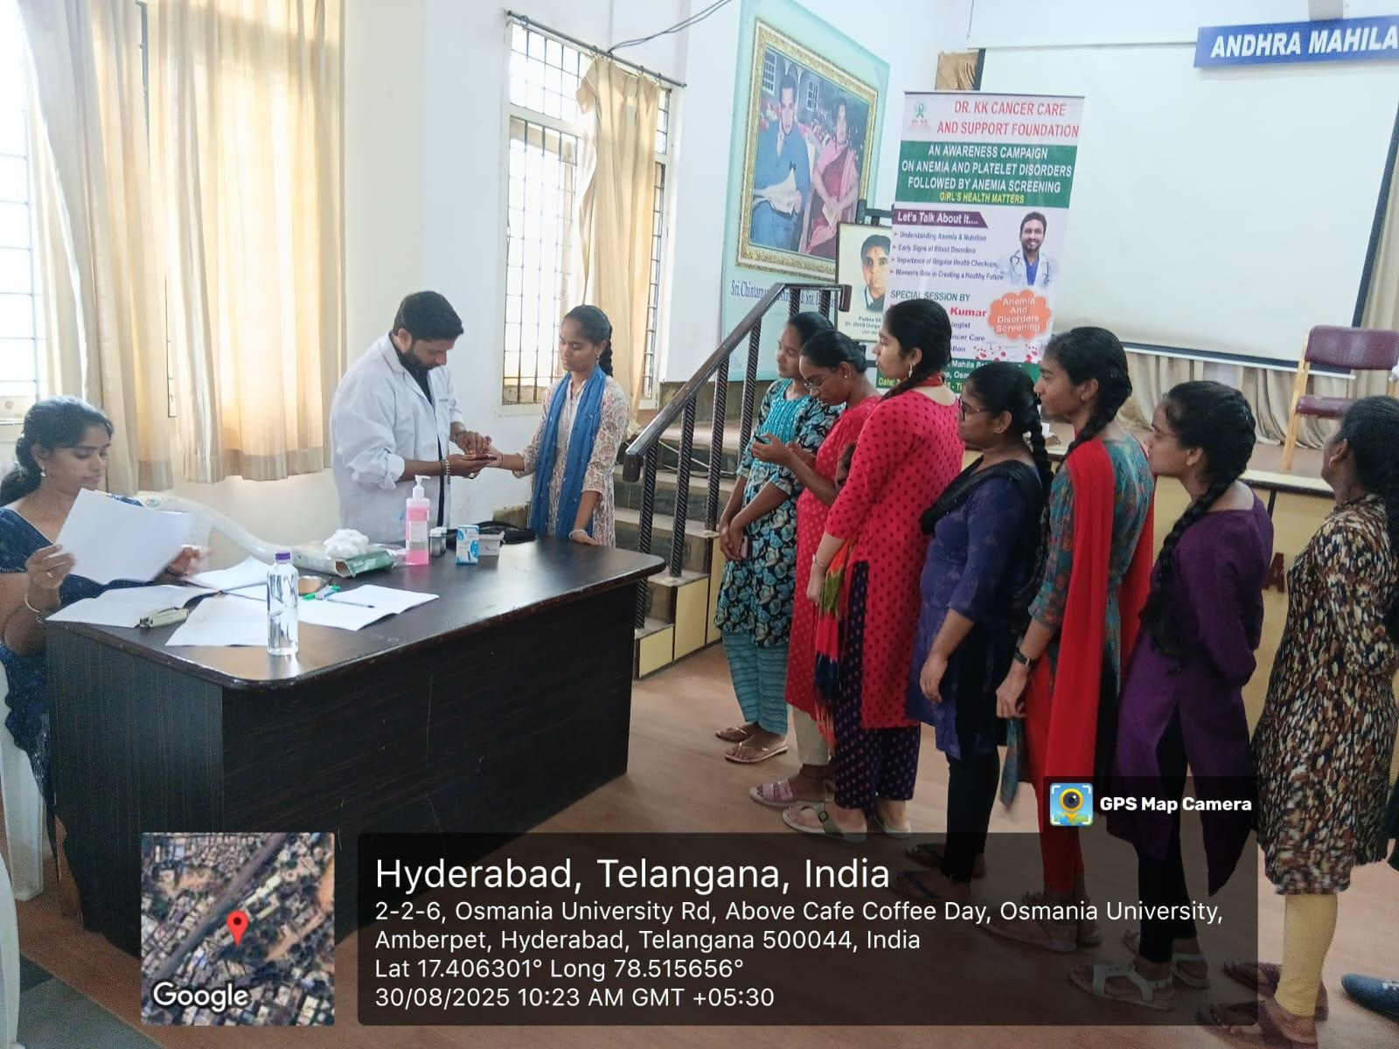

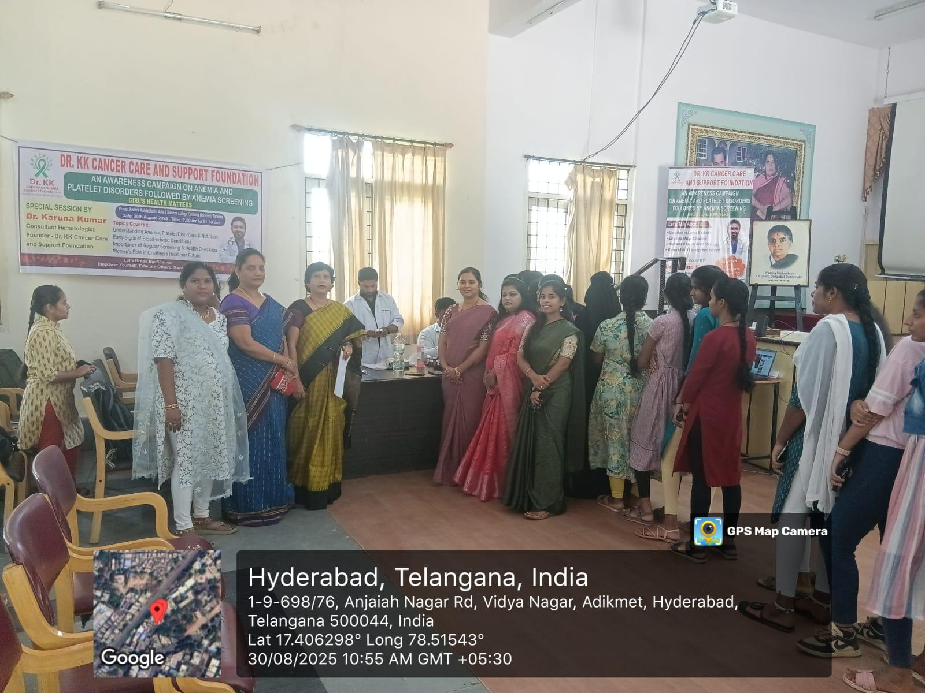

Educational Session:
The educational session, led by Dr. Karuna Kumar, provided an in-depth understanding of anemia’s causes, symptoms, and preventive strategies. It covered various types of anemia, diagnostic techniques, and treatment options available, giving the attendees practical knowledge to safeguard their health.
Interactive Q&A Session:
Following the lecture, an interactive Q&A session was held, where attendees had the opportunity to engage with Dr. Karuna Kumar and clarify any doubts or concerns regarding anemia. This interactive session allowed participants to gain a deeper understanding of the subject and its impact on health.
Health Awareness Materials:
Informational brochures, posters, and handouts containing tips on anemia prevention and the importance of regular blood tests were distributed to all participants. These resources served as valuable references for individuals to keep track of their health status and adopt healthier practices.

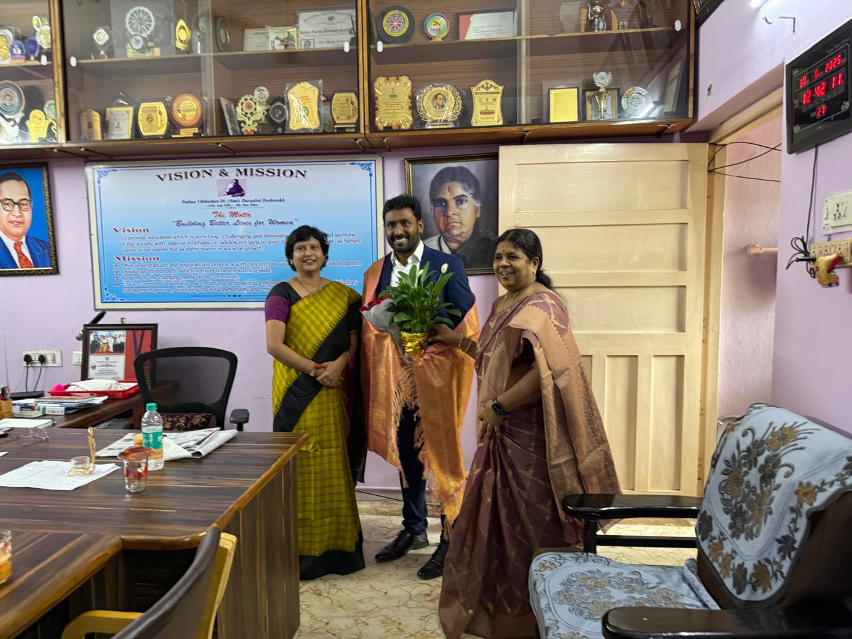

Outcome of the Program:
The anemia awareness program proved to be a resounding success, effectively achieving its goal of educating the participants on the importance of anemia prevention and early detection. The hemoglobin screening initiative provided practical health benefits, as it allowed participants to assess their own health and seek appropriate medical attention if necessary.
By the end of the program, participants demonstrated a clear understanding of the importance of balanced nutrition, regular health check-ups, and the role of hemoglobin levels in maintaining optimal health. Attendees were more aware of the impact anemia can have on their daily lives, and many committed to adopting healthier dietary habits and seeking timely medical advice.
In conclusion, the program succeeded in raising awareness about anemia, reducing the stigma surrounding it, and empowering individuals to take proactive steps to safeguard their health. It served as a timely reminder of the importance of early diagnosis, education, and prevention in tackling health challenges such as anemia.

