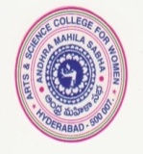
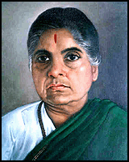
ANDHRA MAHILA SABHA
ARTS & SCIENCE COLLEGE FOR WOMEN
Autonomous - NAAC Re-Accredited, O.U.Campus,
Hyderabad – 500 007

Prof. K. Karuna Devi, Principal I/c has attended a Two - Day National Consulrative Workshop on MBGL Framework for Autonomous and Affiliated colleges under NAAC Reforms held on 11th - 12th August 3025 organised by NAAC, Bengaluru.




